UCD**** School of Electrical, Electronic and Communications Engineering

EEEN10020 Robotics Design Project

# RoboRugby Interim Report

**Team Number:** 10 **Team Name:** Bot the Builder

**Author:** Fergal Lonergan **Student Number:**  13 456 938

**Team Members:** Aaron Collier and Clodagh Dunne

### Declaration

I declare that the work described in this report was done by the people named above, and that the description and comments in this report are my own work, except where otherwise acknowledged. I have read and understand the consequences of plagiarism as discussed in the EECE School Policy on Plagiarism, the UCD Plagiarism Policy and the UCD Briefing Document on Academic Integrity and Plagiarism. I also understand the definition of plagiarism.

Signed: . . . . . . . . . . . . . . . . . . . . . . . . . Date: . . . . . . . . . . . . . . . .

## Introduction

Since late January our team has been formulating and honing a plan which will hopefully capture us the RoboRugby 2014 title in April. During the early weeks of the module we spent our time learning to understand how to build a structurally sound robot using the Lego technic as well as trying to grasp as much of the concepts we need to code our robot so as it will be able to carry out our strategy, which was chosen in Week 5 after much deliberation. Up until now we have been focusing mainly on building our robot, dedicating the coming weeks to programming. Our robot has been built specifically to carry out our strategy and has been optimised over the past few weeks. Finally as a group we have formulated a plan of the work needed to complete our robot before battle and we delegated that work so as to achieve our goals in the specified timeframe.

## Strategy

As a team, we noted from reviewing the past videos that the key factor to winning the RoboRugby tournament was ultimately down to having a good strategy, and then being able to implement it. This is why our team spent many weeks deliberating over what type of strategy we would use in the hopes that we will outsmart our opponents and win this year’s RoboRugby tournament. We attempted to look at the competition from every possible outcome and then formulate a strategy that would cover all the bases in regards to beating whoever our opponents may be.

**1)** **All-out Attack**.

I originally proposed this strategy where the robot began facing the opponent’s goal. The idea was to turn and go straight for the white and yellow balls and the cube in the centre of the table, and collect all of them (cube included). The robot would then proceed in driving back to our own scoring area where it would drop off the cube in our conversion zone whilst collecting the balls it passes. It would then proceed up the right side of the table as we look at it collecting all the balls in its path and dumping them in the opponent’s scoring zone. The intension was to have quite a large collection area as it was hoped that we could collect practically every ball before reaching the opponents try zone. If the robot crashes it would use the beacons to reposition itself. A time limit is set as a failsafe, so if there is ten seconds left and the robot isn’t in the scoring position it stops what it is doing and goes to the conversion zone using the beacon as a guide.

Pros;

* We could potentially have scored a significant amount of points, (8-10) if we don’t get them in conversion zone, (16-20) if we do.
* By clearing out our own scoring zone we reduce the amount of points scored by our opponents, whilst in the process collecting points to take up to the far side of the table.
* The opponents will also get deducted points, hopefully four, from the cube.
* There is the option of dropping a cover or a wall on or in front of our scoring zone preventing the opponent from scoring.

Cons;

* We believed that seeing as there was so many points in the centre of the table that most teams would attempt to claim these balls first and we did not want to crash into the other teams’ robot.
* The cube could prove tricky to deal with, hardware and software wise.
* If the opposing robot builds a wall then our robot has no way of scoring and could become disorientated leaving us with potentially 0 points.

**2) Defend, defend and defend.**

Aaron’s strategy involved our robot facing back towards its own scoring zone. Once the match starts the robot then clears out our scoring zone, as well as dropping a blocker into our own conversion zone. It then proceeds up the right side of the table collecting and counting the balls, then stopping and parking in the opposing team’s conversion zone should we have collected more than 8 balls (there are only 14 balls on table, it was felt that if we had 8 we would almost always win). If we had collected enough we would stay otherwise we hunt. If the robot had crashed it would have used the beacons to reposition itself. A time limit is set so if there is ten seconds left and the robot isn’t in the scoring position it drops everything and goes to scoring position.

Pros;

* The projected score if we got all our balls we intended to collect on our way around into the conversion zone was 22 points. This was more points than would be left on the table.
* The programming involved was relatively simple, dead reckoning could be used for most of the original movement.
* If the robot was quick we could hopefully get into the opposing scoring zone before coming under threat by the opposing robot.
* Simplest strategy to program, apart from ball counter.

Cons;

* Again there was a high likelihood that our robot would meet the other robot if it decided to attack instead of defend potentially ruining the strategy.
* A large collection zone for the balls was required working against the idea of having a small light robot which would suit the strategy best.
* If the opposing robot builds a wall then there is no way of scoring and the robot may just crash into barrier continuously until eventually the 60 seconds runs out.

**3) Fire at will.**

Clodagh suggested that we start by collecting the four balls around the cube, but not the cube itself, then clear out the balls around our scoring zone. The robot could then proceed collect all the balls on the right hand side of the table and then park in the opponent’s conversion zone. If the robot ran out of time and it hadn’t/couldn’t reach the scoring zone then it would use the opponents beacon to point itself in the right direction and “fire” the balls towards the beacon and the conversion zone, using the servo motor as a throwing arm.

Pros;

* If a wall is used then we should still hopefully be able to score some points despite th robot not being able to make it there.
* If a wall isn’t used then we have the potential to score 34 points if all goes perfectly and we get the balls into the conversion zone.

Cons;

* Cube will be tricky to navigate around.
* We have no way in covering or blocking our scoring zone to stop the opposing team.
* Still an extremely high likelihood that we may collide with the other robot if they go for the centre of the table first as well, or even around the table at some point.
* The robot needs to carry a lot of balls.
* The “Firing Arm” may have proved tricky to get working right

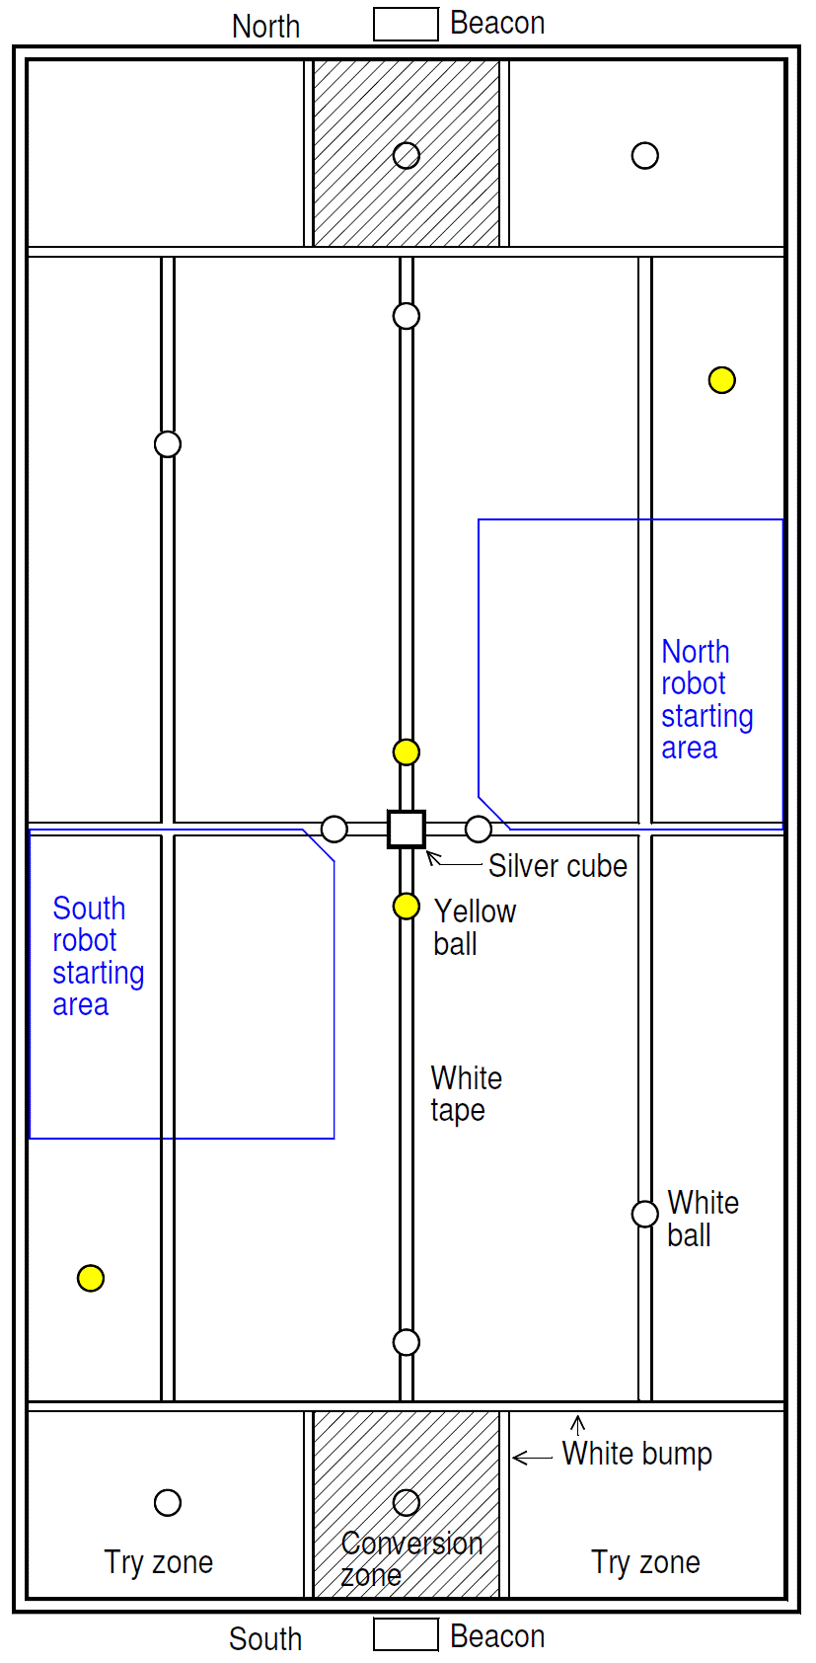

**CONCLUSION:**

All strategies had both positive and negative aspects with no strategy being an obvious choice. It was conceded that having the luxury of several programs pre-programmed into the robot would be ideal, choosing an appropriate strategy to combat the information we would recover over the coming weeks and from the practise matches on the different teams’ strategies. We decided that we needed a failsafe but also that not one of these strategies alone was strong enough to defeat the teams we would face in the RoboRugby competition but that together they could make a strategy that with a bit of luck may win us the title.

## “Bot the builder”, our final strategy

We finally decided on a strategy that incorporated the aspects from all of the previous three strategies as well as having a few new additions of its’ own, in essence making a super strategy:

-We will have an option of three strategies, 2 being quite similar in design to one another with a small tweak added to one in case we are battling a robot that intends to build a wall. The third is a backup strategy if we feel that our first two strategies will be rendered useless against another teams strategy, this also has the added benefit of catching opposing teams by surprise.

- At the start of our programme we will have an option to decide on which strategy we use using the STOP button to alternate between strategies and the START button to choose a strategy

STRATEGY 1

- We will begin facing our defensive beacon.

-We hope to first go back to our own scoring zone and clear out the balls on our side of the table, avoiding the balls around the cube and the cube itself. We have chosen to ignore the cube and surrounding balls as we hope to have a fool-proof primary movement that works the same every single time and we feel that by engaging with variables such as the other robot early on (As they are likely to go for the cube, etc. early on) we could ruin this primary objective.

-We plan to collect the initial five balls on our side of the table in a harvester-like contraption and store them beneath the under carriage of our robot. The under carriage will hold up to eight balls, with a counter to tell the robot when it is full.

-Once the five initial balls are collected we plan to look around the table for three more balls, initially down the side of the table, hoping they have been left untouched in the opening sequences.

-The robot will find the grey zone and stay there once it either: Has collected eight balls, or the timer has gone off for him to find the scoring zone.

-At ten seconds to go (Or however long our actual robot takes to traverse the length of the table plus a few extra seconds) we intend for the robot to search for the beacon for the scoring zone and head towards it, this is part of our failsafe strategy.

-Should the robot be impeded on his way to scoring he will initially try to reverse and move around the obstacle by turning and then finding the beacon again. If that fails and the timer is less than four seconds we plan to use a device on the back of the robot, using the servo, to lift our collected balls up and tip them over the obstacle, like a dumper. We think this is a good idea because, as you have remarked in lectures, the use of a wall or barricade over the scoring zone has become quite popular, so this would be a good way to counteract that.

STRATEGY 2

This is the exact same as strategy one however it has the addition that should we be fighting a team that employs a wall that we feel can be broken that instead of reversing immediately once a collision has occurred, we would instead continue to drive forward slightly testing the wall to see if we can drive through it.

STRATEGY 3

This strategy was added late as a sort of failsafe should we feel that another robots strategy be superior to our own. It will guarantee us some points and may even win us the match. It involves simply driving directly towards all the balls and the cube in the centre of the table, collecting them and then driving into the opponent’s conversion zone and staying there. We believe it will prove as an effective back up.



***Ranking***

-We would implement some changes to our code for use in the ranking round however:

1) We would aim to collect all balls around the cube.

2) We would increase the holding capacity of the robot so that it could accommodate one more ball, so that it could collect all balls on our side of the table and in the centre in one swoop before going to the opponent’s side.

3) We would modify the counter accordingly.

4) We would not utilize the device to tip the balls over.

We feel that getting a good score in the ranking round will be crucial to doing well in the competition, as it will allow us to avoid the "Better" robots until later rounds.

5) We will try to collect all the balls in the ranking round in two sweeps of the board.

## Robot Design

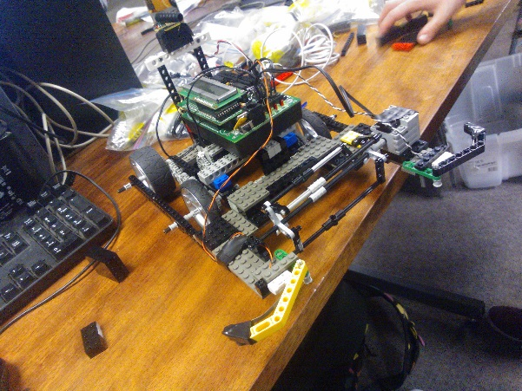 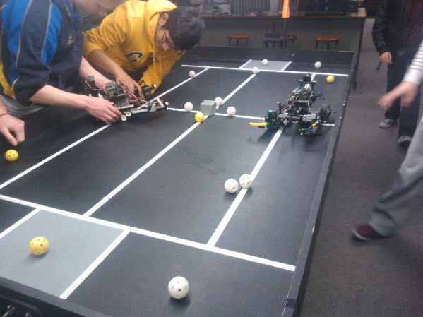

For the final strategy that we have chosen, it is imperative that our robot be fast, strong, have quite a large carriage space for the balls and have a working tipper.

With this in mind we set about first sketching the main important features of the robot and then deciding how we would merge all of these features together. We made the undercarriage of our robot quite large and it now accommodates up to 9 balls. The robot is also extremely long, just inside the limit, as we wanted to use four wheel drive for increased speed, turning accuracy and power when pushing against other robots. We had had a lot of difficulty during the early weeks with slipping gears etc. and set this out as a priority at the start of the build.

We noticed that seeing as the motor for the harvester was added to the left hand side of the robot this made the robot have a tendency to veer off to the left whilst driving so to combat this we decided have the handyboard situated off centre to balance out the robot. We also placed the handyboard directly over the four wheels ensuring that the robot turned evenly.

We made a conscious effort to secure every piece of Lego we added with the result that the robot is now extremely sturdy and strong. We noticed from the initial week that sagging was occurring when the handyboard was added to the robot as well as the robot falling apart sometimes when it hit a wall etc. We wanted to make sure this didn’t happen during the competition and so that is why we tried so hard to build a strong reliable robot.

We also wanted our robot to be fast, so that it can score a few points reliably before the other robot has time to move the balls. With this in mind, we wanted to keep the robot as light as possible, but also holding onto our much needed strength. Our plan involves avoiding collisions, and not bashing the other robot to death, unless we meet walls, so we need to ensure that as well as packing a lot of power that our robot retains its speed.

As the tipper was the most difficult part of the robot to code and build we decided to leave this until last however we made sure to leave ample space so as to add it on later.

### Chassis Design

In keeping with these requirements, we have designed a basic framework for our robot, as shown in the sketch below. The overall length of the robot is 345mm, and the width is 315 , just within the size limits. We felt however that we needed this space in order to collect all the balls that we wanted as well as building a sturdy framework for the harvester and tipper.

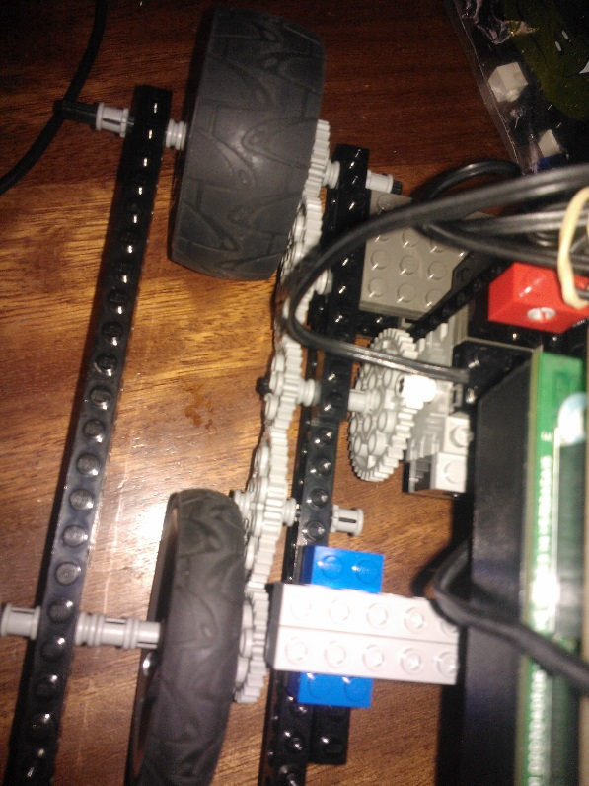

*All images were taken by Clodagh Dunne.*

To get our robot to move as fast as possible, we have decided to use the large wheels. We also decided to use four-wheel drive as this would improve turning and torque as well as adding speed to the robot as there was now no part of the robot that was being dragged. We eventually decided on a 5:1 gear ratio which we feel gives us all of these qualities.

This gear ratio allows our robot to travel quite quickly – at full speed, it can travel the length of the competition table in 8 seconds. It is also extremely strong as when we comment out our collision sensors it takes quite significant force to push against it by hand.

We have compromised a bit on weight in order to add the four wheel drive system however with its’ added benefits we feel that it was a good decision as it does not hamper the speed of the robot that significantly.

### Special Features

The harvester, ball counter and the tipper are our special features on this robot. We have designed the harvester in order to collect the balls as well as ensure that when reversing that they do not come back out of the robot. The ball counter is just going to be a simple switch added to the underside of the support for the handyboard that when the balls come in the will hit the switch adding to the counter. The tipper is probably the most interesting part of the robot. We understand that this is going to be an extremely difficult feat to pull off however the pros far outweigh the cons. We feel that should we get this working, using the remaining servo actuator as the tipper, that this could foil many teams plans and provide us with a unique opportunity to defeat walls in a clever and out of the box way. We have decided not to add this to the robot for the ranking round as it will slow us down slightly but we intend to have it up and running by the competition day. There have been many relevant concerns as to will we be able to complete the tipper up to a competition working standard however the challenge is exciting and welcomed.

## Software

We have decided to have a programme that has a few different options depending on which robot we are facing. This will require gaining information on teams’ strategies however we feel that ultimately this will be beneficial to our teams cause. Our first two options are quite similar with option 2 slightly altered so that we can hopefully crash through some of the walls erected by other teams. Option three came about as a direct result of watching how well Team 21’s strategy did in the demonstration match. It seemed too simple not to include seeing as it did so well and pointed out a major flaw in many teams strategy, the reluctance to go for the so called “Cornucopia”, Hunger Games reference, in the centre of the table.  
Our demonstration strategy was extremely simple using just dead reckoning to navigate ourselves around the table however we did follow our desired route as we went which we still feel is the optimum route to follow in order to gain maximum points.  
We understand that as a group the aspect that we are finding most difficult in the course is the programming and this is why we have devoted so much time to it. Together I feel that we can write a program that will help us capture the RoboRugby tournament but it will take time and a lot of collaboration.

## Performance

In the demonstration event, our robot was drawn against team 20, time on video is 5:50. This left us facing a small, light robot, with quite impressive speed. Their robot didn’t have any evident additional features as ours did with the harvester at the front however it did cover the ground quickly. They didn’t seem to have much programmed into the robot and seeing as we spent the majority of that week ensuring we had a sturdily built robot we also decided that we would just try to use dead reckoning for the test match. We assumed however as most of the robots around us were had decided to clean their own scoring zone first that this was just the “done thing” and hadn’t expected Team 20 to attack our goal first. This messed with our strategy and even though we collected 6 balls on the way around the table, after colliding with the other robot our dead reckoning was off and we did not get the balls in the scoring zone. We did feel that should we implement our strategy as we intend to in the competition that we would have won the game well, however to be beaten on a tie-breaker rule was not a disheartening result as I felt we still managed to show to the other teams that we are capable of being a real threat come competition time. Had we managed to arrive in the scoring zone we would have scored 10 points and 16 point if we got the robot into the conversion zone. Reviewing the results from the RoboRugby competitions for the last few years this would have won us the majority of the games played.

Another thing we noticed was how Team 21’s simple strategy of collecting all the balls and the cube in the centre of the table and driving directly for opponent’s conversion zone would also prove quite effective. It seems that everyone was so sure that the opposing team would try to collect the balls in the centre of the table and were afraid of becoming entangled that we have all disregarded it and by doing so it offers the centre up once again as an extremely viable option to gain some quick and easy points with relatively no threat. This is why we adapted the third option into our strategy.

Also Team 19 who have a robot not too dissimilar to ours had a ball find programme that seemed to collect them quite a lot of balls. They too, unfortunately, did not make it back to the scoring zone however we have been able to note haw they battled the cube with a blocker and used the ball find programme effectively and as a team we have decided these may be viable options to add to our robot as well. I will design the blocker and Clodagh and Aaron will review our ballfinder code.

## Project Plan

All – Black

Aaron – Blue

Clodagh – Green

Myself – Red

### WED 26th March (back after midterm) week 8

* Fix all hardware on robot
* Add hardware for new tipper
* Ensure all previous operations are working
* Add light sensors
* Code robot to drive round selected path, get hit, find beacon and then stop when it gets to grey zone (Aaron will help also)

### WED 2nd April week 9

* Get tipper working
* Test out all parts of our code and mechanical parts (Aaron will help also)
* Have a practice match with another robot
* See what works/ doesn’t work
* Right down any

### WED 9th April (seeding test) week 10

* Spend lab readying robot for the ranking round

### Wed 16th April week 11

* Back to competition
* Final tweaks to robot and to strategy
* Add additional/ backup strategies with final tests
* Do a button menu at start to switch between strategies
* Have a final test match versus someone
* Time to rebuild or manipulate robot depending on performance against other robot

### WED 23rd April week 12

* Reviewing performance in competition
* Disassemble robot

The main tasks that we have to complete are:

* Perfect the tipper mechanism to implement the second part of our strategy;
* Finish writing and testing the program for the ranking round;
* Finish writing the program we intend to use for the competition;
* Make any additional tweaks that become apparent after practise matches.

We do not need the tipper mechanism in the ranking round, so if we have to we can afford to delay that part of the robot building a little if some problem occurs in writing the programme for the ranking round. We should be able to perfect a really good effective programme for the ranking round seeing as we seem to be well on track time wise for the completion of our robot.

So far, we have been working really well together as a team. However we have noticed, especially when coding, that there are times when some of the members of the group are left standing around whilst one or two of the other members work on the robot. As a result we have decided to delegate the work as above. We feel this will be more beneficial and may even leave us with some time left over to really perfect our code etc.

It has been decided that Aaron and Clodagh will be the main programmers, while I oversee the build of the tipper and the testing in conjunction with organising the challenge matches.

## Conclusion

In this report I have explained our strategy for the competition as well as the ranking round. Included is a description of the design of our robot chosen to complement our strategy. I have also described our plan of action for the coming weeks. We believe our strategy will prove tricky to combat from an opponent’s point of view and will prove very effective in both the ranking round as well as the competition. Our demonstration match showed that our robot can collect balls very well as well as that it is both relatively fast and nimble for its’ size as well as packing a lot of power. It also illuminated some problems which we intend to mend over the coming weeks before both the ranking round and the competition. We are lucky enough to be practically finished the physical build of our robot, despite the need to attach the tipper, which we know will prove useful as our code needs a lot of work before the competition, however we feel that we have left ourselves with sufficient time to complete all of this well in time for the ranking round.